**1 Business Background**

The business project relates with Sales of electronics over the World. There are 5 sales channels: Direct Sales, Tele Sales, Catalog, Internet, Partners.

**Benefit**

The main purpose of future BI project is to show the information about sales by channels in different countries in the context of time. It should help to analyze how sums of sales for each channel for a year were increased or decreased. It also will show us the statistic of sales by channels in the context of quarters, it is very important, because for example people will buy less electronics when the weather is good and they plan vacation. In different countries seasons change in different ways. It should show the statistics by month, because, for example, in December there are a lot of holidays and people spend a lot of money on presents, so management can plan the system of discounts for this period. The sales are also depended on day of the month, because people in different regions, companies get paid for their job at the start of the month or at the end and according to it they make purchases. And of course we need the information about amount sold for each day of the week, because at the weekends people have more time to make shopping. Let’s give our business project name “Time distribution analyses”.

1. **Select data of interest**

At this step determine data elements to be included in the model and consider archiving other data that might be needed in the future.

To realize “Time distribution analyses” project, we are interested in sales:

- Channels of sales;

- Sales by periods of time;

- Sales by countries;

1. **Add time to the key**

Add time component to key and resolve resultant changes in the relationships due to conversion of the model from a “point-in time” model to an “overtime” model.

To add time to the key we will generate the dual foreign key. So to describe every sale in history we need to add two parameters: one of them will describe time (event id), when the sale was done, another will describe the product (product id).

- Year;

- Quarter;

- Month;

- Day.

1. **Add derived data**

Calculate and store elements that are commonly used or that require consistent algorithms.

In DW will be stored sums for every product that include in themselves funds to transport costs, different kind of taxes. All kinds of possible loss: defective goods, damaged during the transport.

There are several tables we need:

- sales;

-channels of sales;

-customers;

-products;

-time;

-locations.

1. **Adjust granularity**

**Current business need.**

The main purpose of future BI project is to show the information about sales by channels in different countries in the context of time. For this purpose we need such granularity:

-sales: sum amount sold, quantity sold;

-channels of sales: name of the channel;

-customers: first and last name, gender, year of birth, marital status, street address, postal code, city, e-mail;

-products: product name, product category, product subcategory;

-time: year, quarter number, quarter description, month number, month description, day name, day number in a week, day number in a month;

-locations: country code, country name, country sub region, country region.

1. **Summarize Data**

For the “Time distribution analyses” project was chosen Summaries for Period of Time Data type. Simple accumulations and rolling summaries apply to data that pertains to a period of time. Simple accumulations represent the summation of data over one of its attributes, such as time.

-Sum amount sold for each day;

-quantity amount sold for each day;

1. **Merge Entities**

- Merge Month and Quarter Year and Day tables into one Times table;

-Merge Product Category, Product Subcategory, Products Name tables into Products Table.

-Merge with Countries Country Region and Sub region.

1. **Create Arrays**

- User Gender: M - Male, F – Female;

- Channel: Direct Sales, Tele Sales, Catalog, Internet, Partners.

**8. Segregate**

Times -> quarters and years as the statistic by years and quarters will be generated rarely.

Products -> Categories and Sub Categories.

Country -> Regions and Sub Regions.

Customers ->City->Address.

## 2.1 Business Requirements

– Weekly calculated Amount Sold by country;

– Weekly calculated amount quantity by country;

– Top used channels for each country;

– Should be possible to see statistic by month, quarter, and year by channels;

– Should be possible to see statistic by country, region and sub region;

## 

## 2.2 Technical Requirements

– Statistic period - last 36 month;

– Number of users 100;

– User base is expected to grow;

– System load is 24/7;

– Response time of each query not slower than 15 seconds;

– Security of business information should be provided with help of addition special types of users.

# 3. Solution Sketch

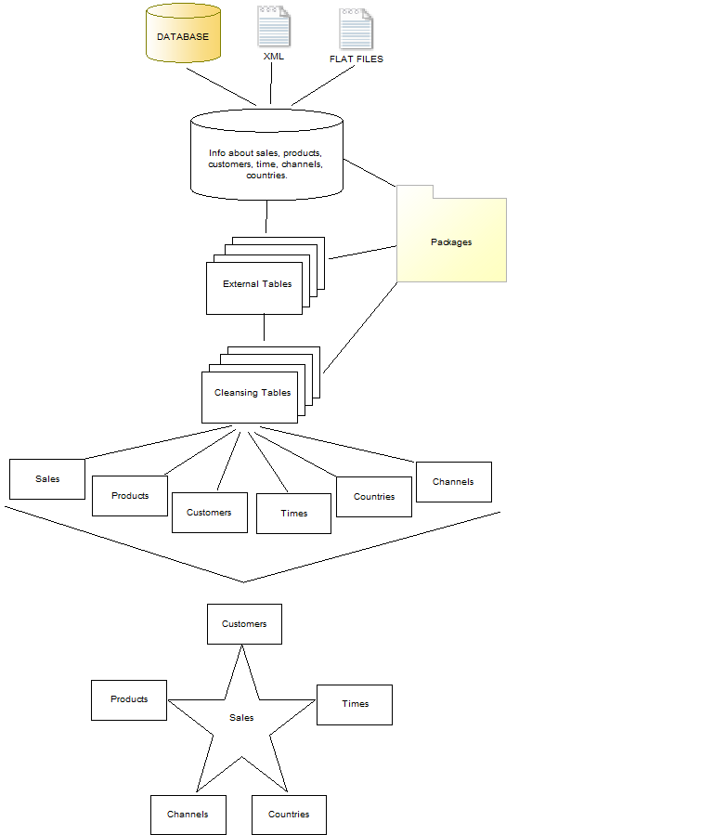

**Summarize Data Plan**

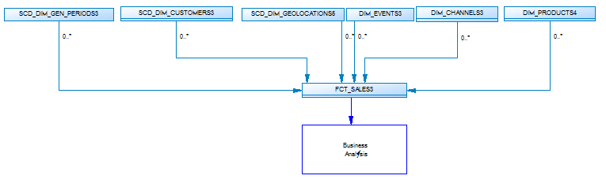

Star Physical diagram.

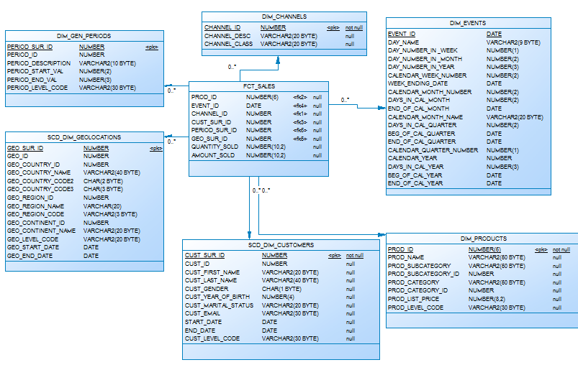

Star Logical diagram.

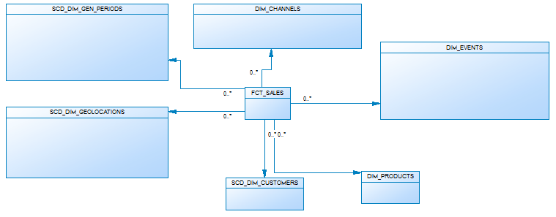

Snowflake Physical Diagram

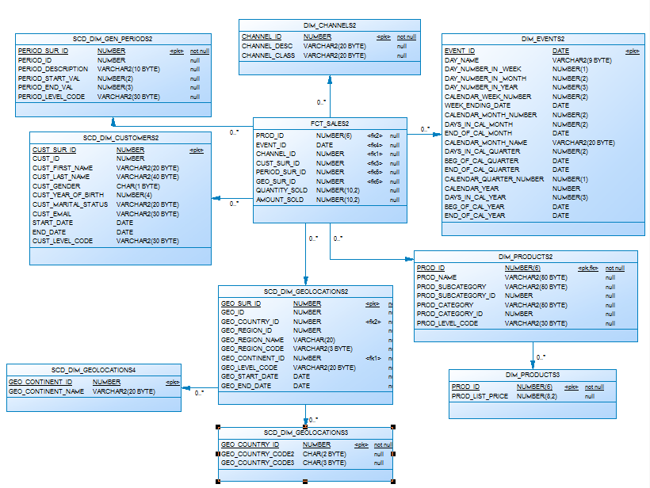

Snowflake Logical Diagram

